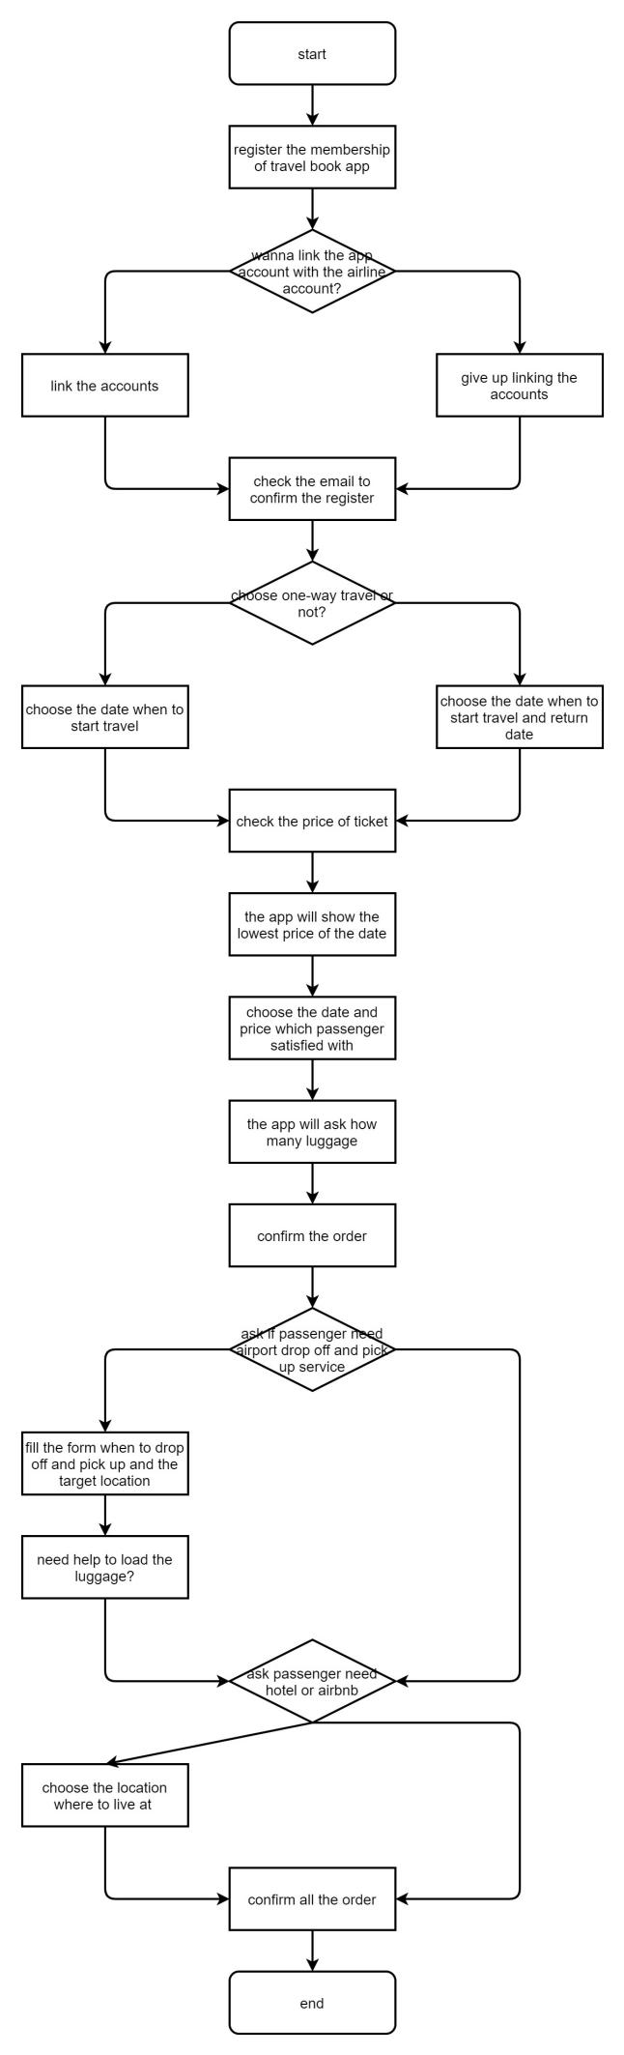

1. The first problem I want to solve is that many app can not link the app account with passengers’ official airline website account, and they can not add the mileage.
2. The second problem is that if passengers have many big and heavy luggage, maybe they cant check in by themselves or arrive at the airport and also the pick-up at airport is a big problem. So the app should offer these services.
3. The last problem is that sometimes the passengers can not find some where to live at. They need to check another app or websites. So the app should offer this service so that the passengers can manage the problems at one time.